**A SMART FAULT DETECTION SYSTEM FOR INDIAN RAILWAYS**

**Minor Project I Report**

**Submitted by:**



**BHUMIKA SHRIVASTAV (<0103IT171029>)**

**ADAMYA SHRIVASTAV(<0103IT171010>)**

**Group No.-6**

in partial fulfillment for the award of the degree

of

**BACHELOR OF TECHNOLOGY**

**IN**

**INFORMATION TECHNOLOGY**

at

**LAKSHMI NARAIN COLLEGE OF TECHNOLOGY**

**KALCHURI NAGAR, RAISEN ROAD, BHOPAL (INDIA) - 462021**

**SESSION JULY DEC 2019**

**Annexure-2**

**LAKSHMI NARAIN COLLEGE OF TECHNOLOGY BHOPAL (M.P.)**

**Department of Information Technology**



**CERTIFICATE**

This is to certify that the minor project titled “A smart fault detection system for Indian Railways” is the bona fide work carried out by **Bhumika Shrivastav,Adamya Shrivastav & Enrollment No.is/are 0103IT171029, 0103IT171010** student/students of B.Tech.(Information Technology) of Lakshmi Narain College of Technology, Bhopal affiliated to Rajiv Gandhi Proudyogiki Vishwavidyalaya, Bhopal, Madhya Pradesh (India) during the academic year 2019-20, in partial fulfillment of the requirements for the award of the degree of Bachelor of Engineering (**Information Technology**) and that the project has not formed the basis for the award previously of any other degree, diploma, fellowship or any other similar title.

**Signature & Seal of HOD, Information Technology Signature of the Guide with Date**

**Lakshmi Narain College of Technology, Bhopal**

**Annexure-3**

|  |  |
| --- | --- |
|  | **Table of Contents** |
| Title Page | i |
| Declaration of the Student | ii |
| Certificate of the Guide | iii |
| Abstract | iv |
| Acknowledgement | v |
| List of Figures | vi |
| List of Tables (optional) | vii |
| Timeline / Gantt Chart(optional) | viii |

1. **INTRODUCTION\***
   1. Problem Definition
   2. Project Overview/Specifications
   3. Hardware Specification
   4. SoftwareSpecification
2. **LITERATURE SURVEY**
   1. Existing System
   2. Proposed System
   3. Feasibility Study
3. **SYSTEM ANALYSIS & DESIGN**
   1. Requirement Specification
   2. Flowcharts / DFDs / ERDs
   3. Design (Use Cases )and Test Cases

3.4Algorithms and Pseudo Code

3.5Testing Process

1. **RESULTS / OUTPUTS**
2. **CONCLUSIONS / RECOMMENDATIONS**

**REFERENCES**

**APPENDICES**

A.1 Details of software/simulator if any

A.2 Steps to execute/run/implement the project

A.3 Coding if any

**WEEKLY MONITORING REPORT**

**Abstract**

This project is intended to propose a device which can automatically detect any cracks in railway tracks. The created device will be attached into the train engine and it consists of a sensor that will detect crack a few meters away and as soon as any crack is detected the train driver will get a signal so he can apply emergency brakes along with it the authorities will be notified with the correct location at which the fault is detected. The proposed approach is benign because the Indian Railway is the biggest railway network in Asia so there should be an efficacious methodology to detect and correct any kind of mishap due to railway tracks. The proposed system is different from others because the device is embedded in the train itself, which could reduce manual work and labour wages. This project aims at the eradication of any kind of casualty in Indian Railway and if this system creates, even if a small refinement it will make a difference in the nation.

Keywords- IoT, Arduino Uno, Ultrasonic Sensor, IR Sensors, GPS, GSM, Train 1 8.

**ACKNOWLEDGEMENT**

I have taken efforts in this project. However, it would not have been possible without the kind support and help of many individuals and organizations. I would like to extend my sincere thanks to all of them.

I am highly indebted to (Prof. Shubha Mishra) for their guidance and constant supervision as well as for providing necessary information regarding the project & also for their support in completing the project.

I would like to express my gratitude towards my parents & member of (LNCT Group of Colleges)for their kind co-operation and encouragement which help me in completion of this project.

I would like to express my special gratitude and thanks to industry persons for giving me such attention and time.

My thanks and appreciations also go to my colleague in developing the project and people who have willingly helped me out with their ability

**List of figures**

1. Arduino
2. Block diagram of IR sensor
3. IR Sensor
4. Ultrasonic Sensor
5. GPS Module
6. Flow chart

**CHAPTER 1**

**INTRODUCTION**

* 1. **Problem Definition**

India has around 65,000 route kilometres of railway lines spread across the entire country. Everyday Indian Railway carries around 25 million people to their destination. The Indian Railway is rank as the fourth largest network of the railway in the world, but still, our safety measures are substandard as compared to the international standards. According to the annual report of railway, the railways said that seventeen (17) accidents out of total fifty-nine (59) in 2018-19 had taken place due to defect on the tracks. The tracks generally go unnoticed due to improper maintenance and irregular track monitoring. The proposed system is competent enough to deal with any kind of shortcomings in the existing system of monitoring tracks. The system is completed with the help of the Internet of things which is about to transform the next decade. According to a survey 50 billion devices will be IoT connected by 2020. The primary goal of using IoT is to particularly minimize operating expenditures when automation devices like sensors and actuators have become internet-enabled devices. The proposed system would enable running high-speed trains. This project will reduce the number of accidents due to a train derailment. The proposed system will also have a sensor to detect if there is any obstacle. With the help of this sensor, we could reduce the death rate of humans as well as animals and the collision of the train can also be controlled. This article gives a full description of the problem definition and how to implement this system to solve the problem stated above.

* 1. **Project Overview /Specification**

The device consists of an Arduino UNO microcontroller & some sensor i.e. Ultrasonic Sensor, PIR Sensor & IR Sensor. All the sensors are attached to the Locomotive (Engine) & can sense range greater than 200m.

Every object having temperature greater than perfect zero release thermal energy in the form of radiation. We humans are radiated at a wavelength of 9-10 micrometres. The PIR sensors are adapted to perceive this IR wavelength which only gets disgorge when a living being arrives in their vicinity. The term “pyroelectricity” means: heat that generates electricity. The PIR sensing element consists of 2 slots wherever each the slots build-up of IR Sensitive materials. below the conventional condition wherever there's no optical illusion before of the sensing element each the slots within the sensing element senses constant quantity of infrared light. once there's motion before of the sensing element, sort of a human or a cat, their radiation is scan by one amongst the slotst 1st and therefore the differential turnout between the 2 slos becomes positive. because the person moves away, the second slot detects the radiation and therefutput pulses, the motion is detected

ore the differential output can flip negative. supported these output pulses the motion is detected.

The ultrasonic sensor works by creating a 10-microsecond pulse and then determines the duration taken by that pulse to reach the object then bounce back. Knowing the speed of sound in air, we can then evaluate the distance of the object which reflected the pulse. Remember that the pulse travels to the object and then back again so we need to divide the time by two to calculate the distance.

The device is coded for all the sensors according to the work performed by the sensors using an appropriate programming language for Arduino. An Ultrasonic Sensor is used to detect cracks in the tracks. PIR sensor is used to detect any obstacle ('human or other trains on the same track'). IR sensor is used to detect the distance of the fault from the Locomotive. An alarm is attached in the driver's cabin, which is also connected with the device. So that if any fault or obstacle is detected by the sensors the driver will directly get notified along with the location. After that, the driver can apply emergency brakes to stop the train.

A GPS-GSM system is also connected to the device. This GPS-GSM system will give the exact location of the fault or obstacles. A message is also sent to the concerned authorities so that a rescue team could reach as soon as possible to the location.

**1.3Hardware Specification**

1. **Arduino UNO**: The Arduino UNO is a chipset that works on AT mega328. Arduino UNO Consist of 14 digital input/output pins where six pins can be used as Pulse Width Modulation outputs, & other six pins are used as analog inputs. It contains Sixteen-Megahertz (MHz) resonant circuit, a USB connection, a power jack, a header, and reset button. It also contains everything which is needed to support the microcontroller; So that, we can connect it to a machine with a USB cable & also power it with an adapter (DC current) or battery to start the chipset.

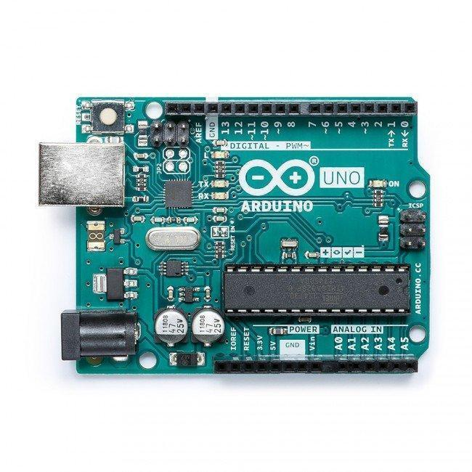

Fig 1. Arduino

**2) IR/PIR Sensor***:* The full form of IR Sensor is Infrared Sensor. An IR sensor is used to ferret out the obstruction or barriers & PIR Sensor is used to measure the distance of that obstruction or barriers.

This thing can be easily understood by the fig .2 shown below which is a model of working on an IR Sensor. The IR sensor releases Infrared lights and gives a signal when it detects any obstacle as reflected light.

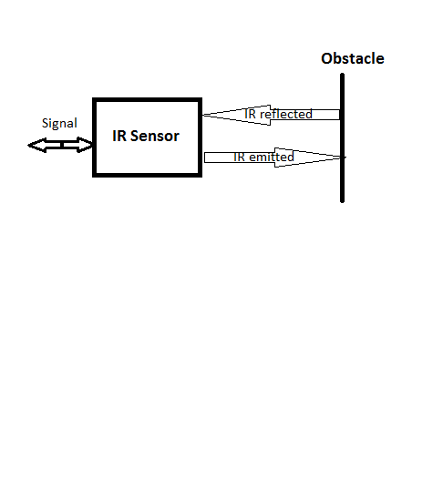

Fig 2. Block Diagram of IR sensor

An IR sensor comprises of a producer(emitter), identifier(detector) and related hardware. The circuit required to make an IR sensor comprises of two sections; the producer circuit i.e. An emitter circuit and the collector circuit. The producer(emitter) has been just an IR LED (Light Emitting Diode) and the finder is basically an IR photodiode which is touchy to IR light of a similar wavelength as that transmitted by the IR LED.

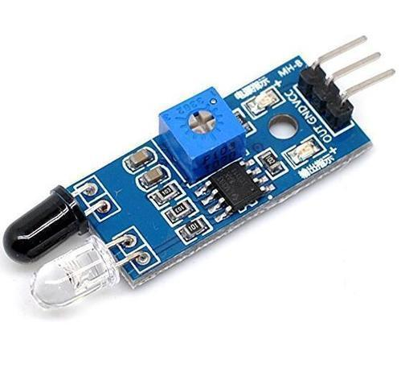

Fig 3. IR Sensor

**3)Ultrasonic Sensor*:*** An ultrasonic sensor containing a 4-pin setup whose pin named as Vcc, lever, reverberation (echo), and earthing.It gets to focus by decoding the reflected sign. The sensor produces sound waves in the ultrasonic range by changing over the electrical vigor into sound, then after getting the reverberation sign believers the sound waves into electrical vitality.

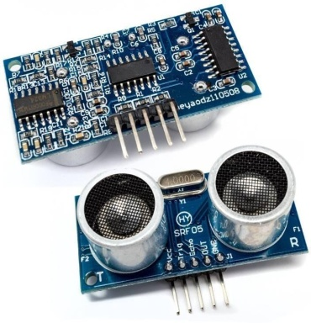

**Fig. 4. Ultrasonic Sensors**

**5)GPS Module*:*** Worldwide Positioning Module (GPS) is a satellite route framework used to find/locate the ground position of an item.A GPS beneficiary figures its role sincerely with the aid of timing the sign sent with the aid of the GPS satellites high over the earth. The position is then proven with a moving map show or scope (latitude) and longitude**.  
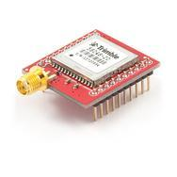**

**Fig. 5. A GPS Module**

**1.4 Software Specification**

The open-source Arduino Software (IDE) makes it easy to write code and upload it to the board. It runs on Windows, Mac OS X, and Linux. The environment is written in Java and based on Processing and other open-source software. This software can be used with any Arduino board.

**CHAPTER 2**

**LITERATURE SURVEY**

**2.1 Existing System**

According to Indian Railways currently the method used in railways for crack detection is an inspection by foot, Trollies, locomotives, and rear vehicles. There are two types of track recording car one mechanical and the other electronic. These cars make a continuous record of track geometry under load conditions.

The car moves on the track and checks if there is any wear and tear on the tracks. They also use IR sensor, but it is not very accurate because manual work is not possible for every railway network. A system gang patrolling is also used which is implemented by foot along the tracks during the rainy season.

Saurabh Srivastava and his teammates have proposed a vehicle for detecting crack using IR sensor array assembly which tracks the exact location of faulty tracks and informs to the nearby railway station [1].

The team from SRM group of colleges Lucknow has proposed a system that detects cracks using Arduino mega power by solar panel along with the laser source. They have also used GSM and GPS module to give an exact location of the crack to authorities via SMS and a link to open location on Google Maps [2].

Rizvi Aliza Raza has presented a model in IJARIIT which is capable of taking pictures of the track and compare it with the old database and also sends a message to the authorities about the fault detected [3].

**2.2 Proposed System**

The proposed system is different from other literary works in many aspects like this system consists of an alarm that will notify the driver about any sort of crack or any animal or human being found. So, the driver could apply emergency brakes to stop the train. The notification given to the driver would be before hundreds of meters so there would be no mishap by applying brakes on the train running at high speed. Along with this notification and location about crack would also be sent to authorities to repair it as soon as possible. In our work, we have also taken care of animals and human beings which come under the train due to some cause so to prevent this we have used a sensor for detecting objects.

The work proposed in this paper is based on IoT which is a leading technology in the world. In the era of automation if Indian Railway will opt for this method it will surely increase a feather on the cap of our nation.

**2.3 Feasibility Study**

**Economical feasibility** The proposed system designed for Indian Railways is economically feasible because according to our observations and the statistical data taken into account the total cost for making the product for one train would not increase more than 50K.

**CHAPTER 3**

**SYSTEM ANALYSIS & DESIGN**

**3.1 Requirement Specification**

Arduino- uno microcontroller

Ultrasonic Sensor

IR Sensor

Alarm

Wires

Connecting rod

GPS-GSM

Wi-Fi

LCD Display

**3.2 Flowchart**

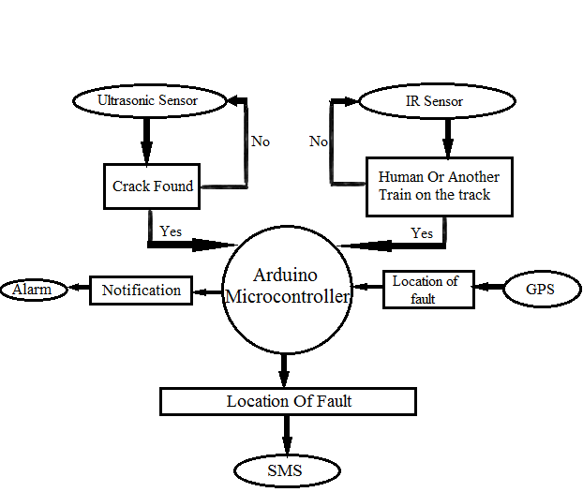

Fig .7 Flow Chart

**3.3 Design and Test Cases**

1. Assemble all the components of the IoT platform.

2. Connect 2 ultrasonic sensor, IR sensor, PIR sensor and GPS along with Wi-fi module to the Arduino board and make them function together .

3. Attach an alarm in the engine connected to Arduino .

4.Put an if- else condition in the code so as soon as the crack is detected the alarm notifies the driver.

5.To run the prototype use 5V power supply.

6. To function IoT use any programming language.

7. The device is ready for attaching it into the train engine.

**Test cases:**

* Arduino gets turned on as soon as connected to a power supply.
* The electric dc motor connected to the locomotive starts and the locomotive starts running.
* The lcd display connected to the locomotive displays the current running status of locomotive.
* The ultrasonic sensors attached displays the data on lcd display.
* As soon as the crack is detected the buzzer gives digital output HIGH and start ringing.
* The crack is detected when the locomotive is few metres away from the crack so the brakes can be applied safely.
* Reset the arduino to run the locomotive again

**3.4 Algorithm and Pseudo Code**

#include <SoftwareSerial.h>

//sensor lx

#define echoPin1 7 // Echo Pin lx

#define trigPin1 6 // Trigger Pin lx

//sensor rx

#define echoPin2 5 // Echo Pin dx

#define trigPin2 4 // Trigger Pin dx

#define LEDPin 13 // Onboard LED

const int buzzer=11;

int minimumRangelx = 10; // Minimum range neede

int minimumRangerx = 10; // Minimum range needed

long durationlx, distancelx; // Duration used to calculate distance

long durationrx, distancerx; // Duration used to calculate distance

// The serial connection to the GPS device

SoftwareSerial ss(RXPin, TXPin);

void setup() {

Serial.begin (9600);

pinMode(trigPin1, OUTPUT);

pinMode(echoPin1, INPUT);

pinMode(trigPin2, OUTPUT);

pinMode(echoPin2, INPUT);

pinMode(LEDPin, OUTPUT); // Use LED indicator (if required)

}

void loop() {

/* The following trigPin/echoPin cycle is used to determine the

distance of the nearest object by bouncing soundwaves off of it. */

digitalWrite(trigPin1, LOW);

delayMicroseconds(2);

digitalWrite(trigPin1, HIGH);

delayMicroseconds(10);

digitalWrite(trigPin1, LOW);

durationlx = pulseIn(echoPin1, HIGH);

//Calculate the distance (in cm) based on the speed of sound.

distancelx = durationlx/58.2;

if (distancelx >minimumRangelx){

digitalWrite(buzzer,HIGH);

}

else {

/* Send the distance to the computer using Serial protocol, and

turn LED OFF to indicate successful reading. */

digitalWrite(buzzer,LOW);

Serial.print(distancelx);

Serial.println( " cm LX ");

// digitalWrite(LEDPin, LOW);

}

delay(25);

digitalWrite(trigPin2, LOW);

delayMicroseconds(2);

digitalWrite(trigPin2, HIGH);

delayMicroseconds(10);

digitalWrite(trigPin2, LOW);

durationrx = pulseIn(echoPin2, HIGH);

//Calculate the distance (in cm) based on the speed of sound.

distancerx = durationrx/58.2;

if (distancerx > minimumRangerx){

digitalWrite(buzzer,HIGH);

}

else {

/* Send the distance to the computer using Serial protocol, and

turn LED OFF to indicate successful reading. */

digitalWrite(buzzer,LOW);

Serial.print(distancerx);

Serial.println( " cm RX ");

//digitalWrite(LEDPin, LOW);

}

//Delay 50ms before next reading.

delay(25);

}

**3.5 Testing Process**

* Connect 2 ultrasonic sensors together and make them work together.
* Connect a buzzer to test the ultrasonic sensor
* Attach a gps and compare the correct location with gps reading
* Make all the hardware components run together.

**CHAPTER 4**

**RESULTS/OUTPUT**

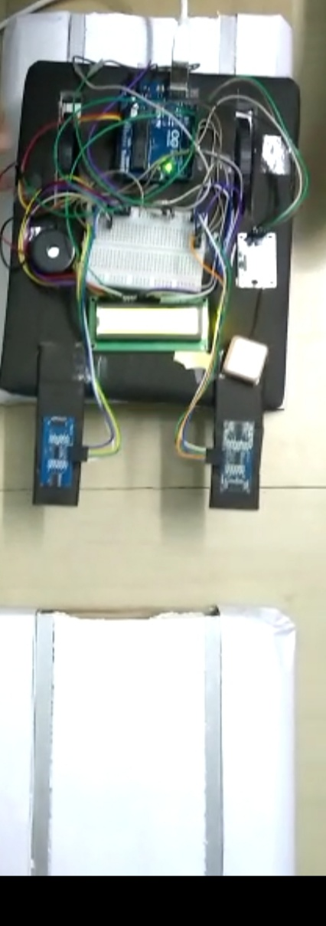

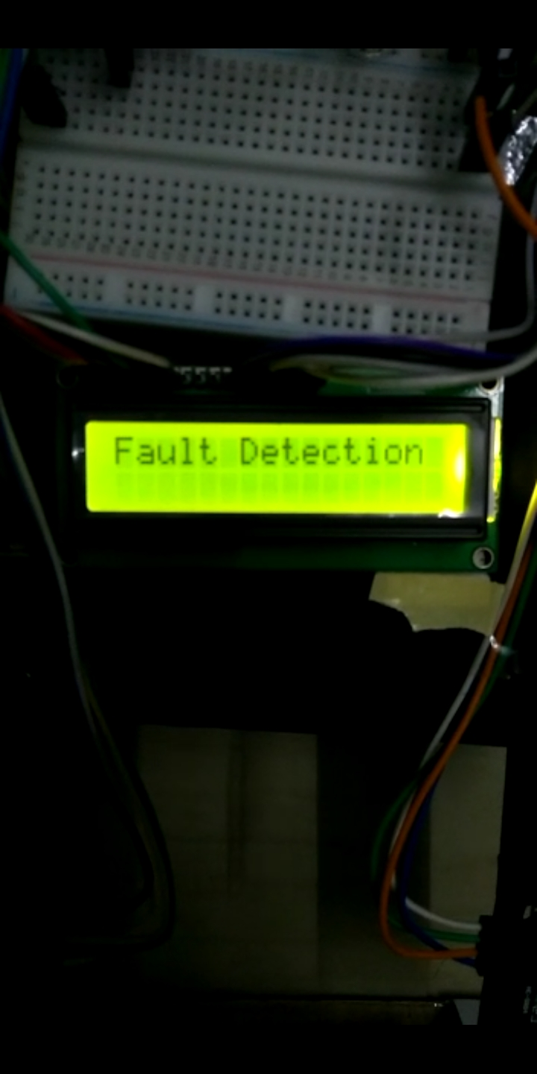

**CHAPTER 5**

**CONCLUSIONS/RECOMMENDATIONS**

In the future, the proposed system will also be connected to networking & communication device. So, if any fault is detected the system will automatically broadcast the location and type of fault to every train coming on that route. If the broadcast is done, then the other trains can be diverted or blocked off (Stopped) to avoid any inconvenience.

Along with it, the system will conjointly use deflectors, so that if there's any high curvature track then the deflectors can transmit the waves in keeping with the curve.

**REFRENCES**

1. Saurabh Srivastava, Ravi Prakash Chourasia, Prashant Sharma, Syed Imran Abbas, Nitin Kumar Singh, “Railway Track Crack detection vehicle”, IARJSET, Vol. 4, pp. 145-148, Issued in 2, Feb 2017.
2. Utkarsh Mishra, Vistar Gupta, Syed Mohd. Ahzam, and Shiv Mani Tripathi, “Google Map Based Railway Track Fault Detection Over the Internet”, International Journal of Applied Engineering Research, Vol. 14, pp. 20-23, Number 2, 2019 (Special Issue).
3. Rizvi Aliza Raza, Khan Pervez Rauf, Ahmad Shafeeq, “Crack detection in Railway track using Image processing”, IJARIIT, Vol. 3, pp. 489-496, Issue4.
4. B.R.BalaJaswanth and Ch.Muneendra Rao, ” Crack Sensing Scheme in Rail Tracking System”, Int. Journal of Engineering Research and Applications, Vol. 4, pp.13-18, Issue 1(Version 2), January 2014.
5. R.V.K.Charan, “Early detection & alarming of a transverse crack in a railway track (modified)“, International Journal of Scientific & Engineering Research Vol. 4, Issue 1, January-2013.
6. S. Ramesh, “Detection of Cracks and Railway Collision Avoidance System”, International Journal of Electronic and Electrical Engineering, Vol. 4, pp. 321-327, Number 3 (2011), January-2011.